Question 1
Match the following terms and definitions

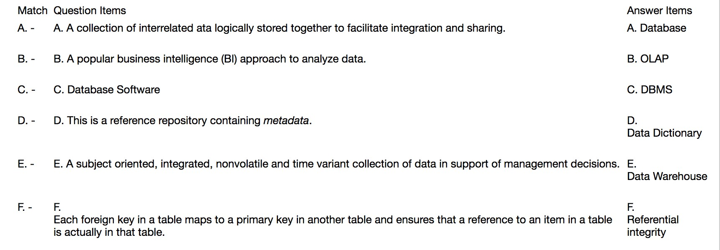

Question 2

Database processing offers several advantages over traditional file processing. One advantage is:

Databases usually store small amounts of specific information
Databases totally eliminate data redundancy
Databases provide for data independence
Each database application has its own unique data file, data is not shared
Databases store information only on PCs, making data more accessible

Question 3

General database term that refers to the organization of data as a conceptual framework; how a database is constructed. It is the complete logical view of a database.

Dataset
Database schema
Relational table
SQL
DBMS

Question 4

________ is/are raw facts.

A DBMS
Data
Metadata
Information
Constraints

Question 5

The relational data model represents data in the form of:

Tables
Entity instances
Nodes and branches
Programs
Unstructured data

Question 6

Which relational term is synonymous to the word 'column'?

Program
Domain
Relation
Tuple
Attribute

Question 7

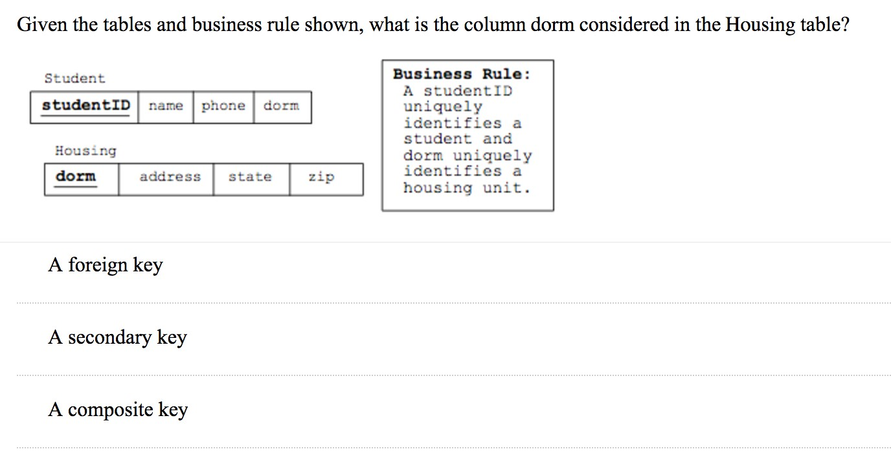
A primary key

Question 8

Given the tables and business rule shown, what is the column dorm considered in the Student table?
A foreign key
A secondary key
A composite key
A primary key

Question 9

A distinguishing feature of the relational data model is that:

Primary keys exist
There is no redundant data
All tables include composite keys
Application programs cannot be written to access data – only interactive SQL is used Relationships are inherent within the data – there are no explicit linkages between tables

Question 10

_________ occur when all changes in redundant data are not made correctly.

Data anomalies
Domains
Metadata
Tuples
Attributes

Question 11

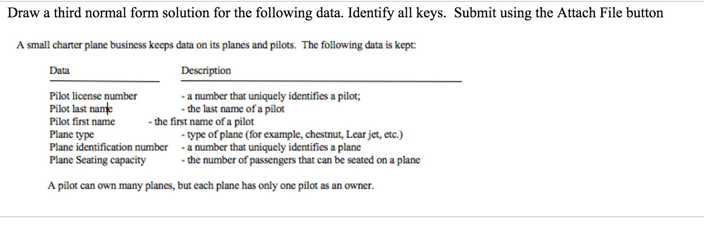

Question 12

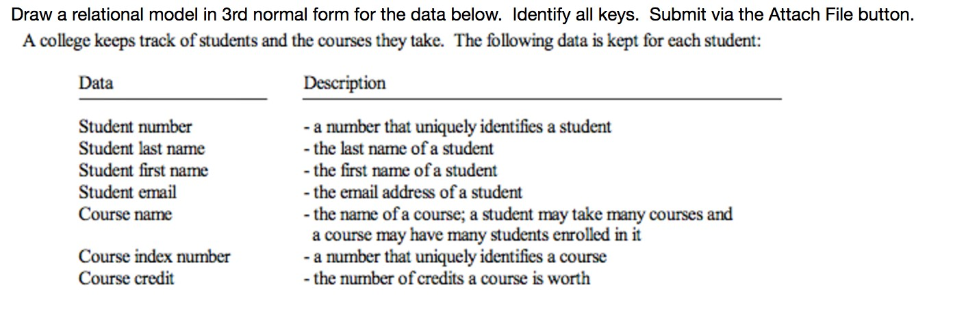

Question 13

Which SQL statement corrrectly uses a function to display the total salary of all employees?

display total salary() of employees; list count(salary);
select count(salary) from employees; display add(salary) from employees; select sum(salary) from employees;

Question 14

In SQL, the ___________ operator is another method of using OR logic.

IN

OUT

BETWEEN

LIKE

XOR

Question 15

In SQL, to place a new instance (record) into a relation (table), the statement used is:

insert update add place put

Question 16

This keyword is used in SQL expressions to select partial values. It is used with wildcard characters (% -), which represent unknown characters in a pattern.

within from
like
update from

Question 17

Creating an ERD (Entity Relationship Diagram) is an example of:

SQL
Normalization
Creating a data model to represent user requirements
Designing a physical database model
Object-Oriented Programming

Question 18

In an ERD, these are attributes that name, or distinguish, entity instances.

Relations or tables
Cardinality constraints
Raw attributes
Primary keys or identifiers
“crows-feet”

Question 19

Given the statement: create new table client(clientID integer primary key, firstName varchar(20), lastName varchar(20));

select the incorrect syntax/error from the list below:

create new primary key varchar(30) table

Question 20

In the box below, write an SQL query statement that shows all of the data in a table called bank.



Question 21

Given a table called inventory that contains an integer field called inStock, write an SQL query statement in the box below that shows all of the data contained in the table for which the inStock record value is greater than 100.



Question 22

Given a table called account that contains a varchar field called accountType and a numeric field called accountLimit, write an SQL query statement that shows the data for just these two fields for all of the records in the table with an account type of savings and that have a limit greater than $100,000.



Question 23

Given a table called movie that contains a field called movieName, write an SQL query statement that shows all of the data contained in the table sorted by movieName (in default ascending order).

Question 24

Given a table called bank that has a 1:N relationship with a table called customer, write an SQL query statement in the box below that shows a customer's last name and their associated bank name.
Note: The bank table contains the fields: bankName (a varchar field) and bankID (a numeric field that is a primary key). Thecustomer table contains the fields: customerLastName (a varchar field), customerID (a numeric field that is a primary key), andbankID (a numeric field that is a foreign key).

Question 25

In an ERD, this specifies the number of instances of one entity that are associated with another.

Primary key
Weak entity
Attribute
Foreign key
Cardinality constraint

Question 26

In an ERD, a __________ describes an association among entities.

join Object data anomaly cascade Relationship

Question 27

A ___________________ is a precise description of a policy, procedure, or principle within a specific organization. It is a statement that defines or constrains some aspect of the business.

business model database table business rule Dimension Denormalized relation

Question 28

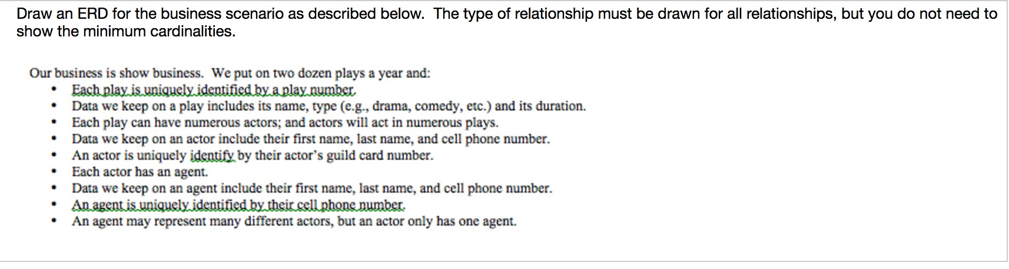

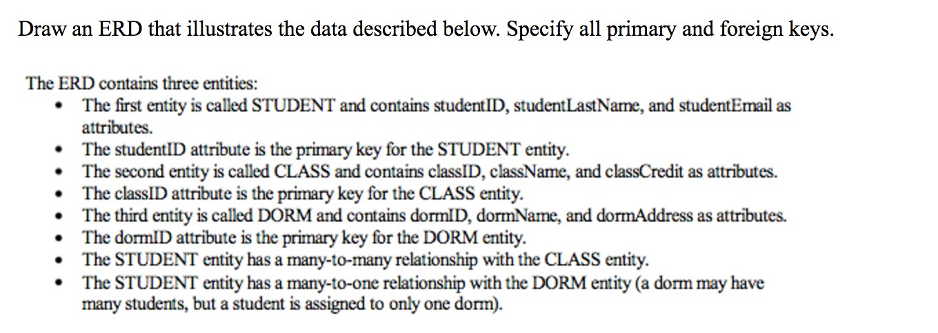
Question 29

Question 30

This is a standard means for defining the structure of documents and for transmitting documents from one computer to another. It is important for database processing because it provides a standardized means of submitting data to a database.

HTML
XML
JavaFK
DDL
Vertical fragmentation

Question 31

In data administration, one remedy for the inconsistencies caused by concurrent processing is to prevent multiple applications from obtaining copies of the same rows or tables when those rows or tables are about to be changed. This remedy is called:

Encryption
The deadly embrace Resource locking
Referential integrity
Legal strategies

Question 32

Database administration includes database security – the process of protecting the database. The goal of database security is to ensure that only authorized users can perform authorized activities at authorized times. This goal is usually broken down into two parts:

Authentication and authorization
Legal strategies and encryption
Resource locking and the deadly embrace
Data validation and data consistency
Locking granularity and authorized legal actions

Question 33

Which SQL command is used to undo changes made by a transaction to the database?

quit undo cancel rollback close

Question 34

A modeling technique used to represent the multi-dimensional data stored in a data warehouse:

Data dictionary
Data mine
SQL constraints
Denormalization
Star schema

Question 35

Data warehousing is a paradigm specifically intended to:

Provide vital strategic information
Support processing of business transactions Reduce the size of a database
provide for easy updates to data in the database
Avoid the use of SQL

Question 36

Edgar F. Codd is regarded as the "father" of relational database theory. Although he spent the majority of his working years in the U.S. as an employee of IBM, what English speaking European country was he born in? (Hint: it's part of the UK, but not Scotland, Wales, or
Northern Ireland.)

